Develop The Web Application Using Node-RED

|  |  |
| --- | --- |
| Date | 10 November 2022 |
| Team Id | PNT2022TMID31893 |
| Title | Hazardous Area Monitoring for Industrial Plant using IoT |

**Node red flow**

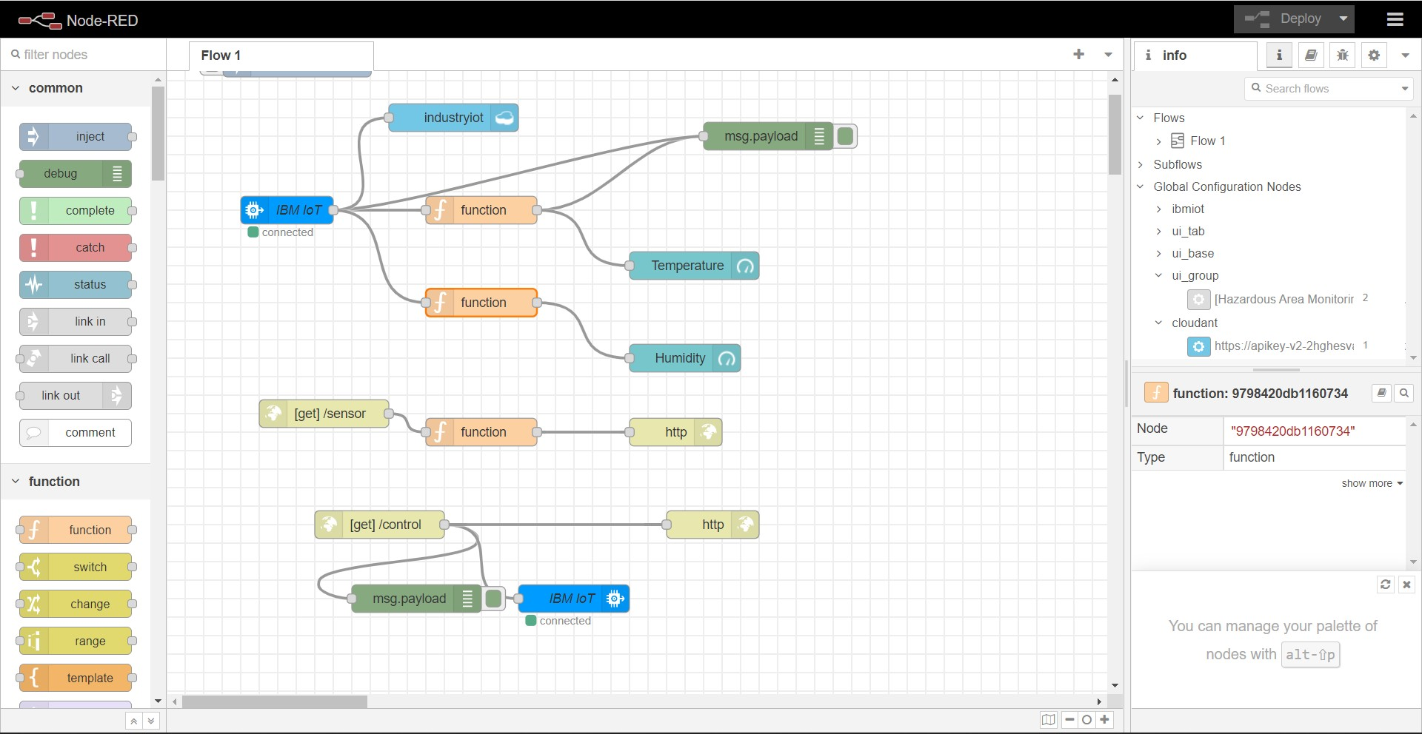

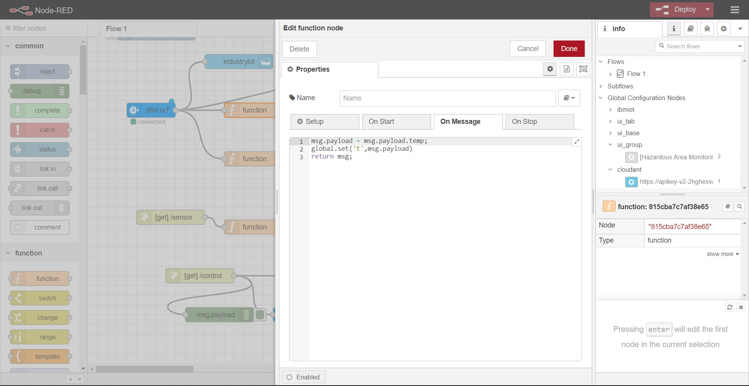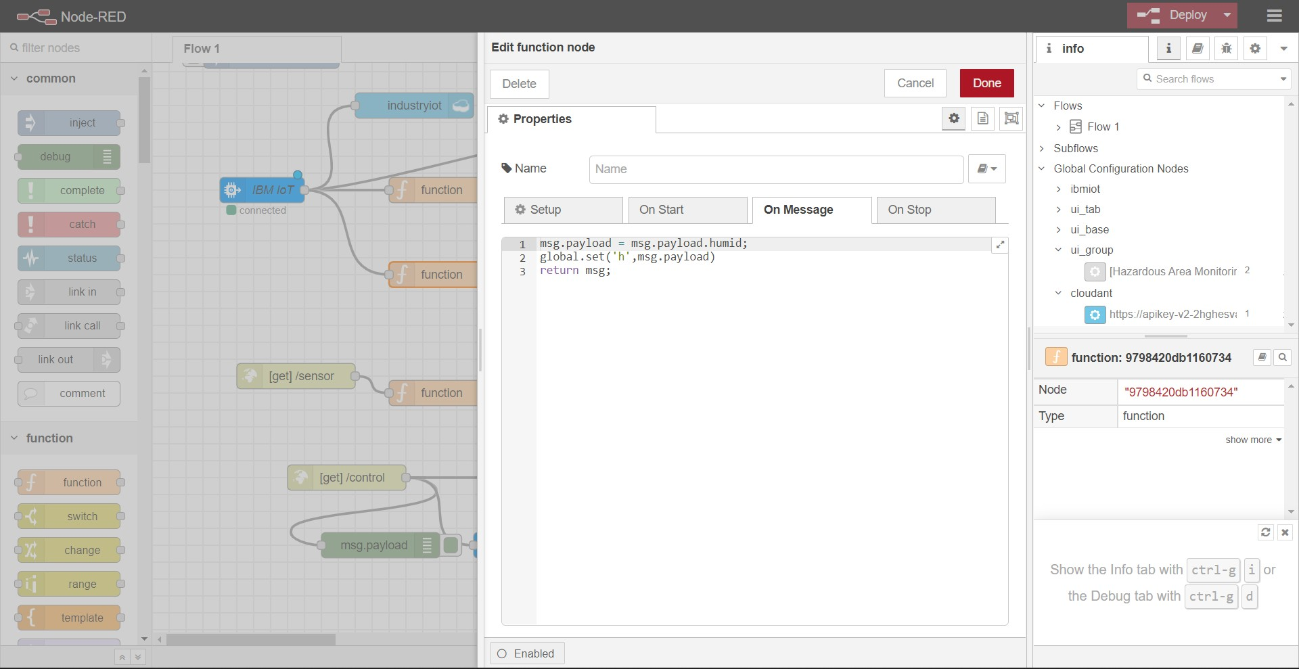**Function blocks**

